 |  | Reservation Application  March 27(Fri.)–28(Sat.), 2026 대한견주관절의학회 국제학술대회 |  |  | 
*Check In Date: 2026. |  |  | *Check Out Date: 2026. |  | 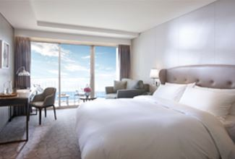  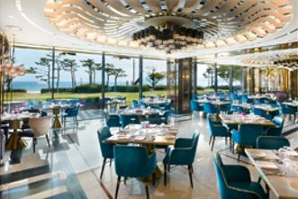  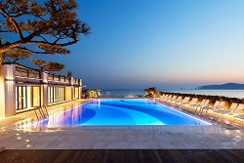
*No. of Persons:
*Name (Family/Given):
*Telephone: |  |  | *E-mail:
CREDIT CARD INFORMATION (For Guarantee)
*Credit Card: ☐Other ☐Visa ☐Masters ☐Amex(4digit-number: )
*Credit Card Number: |  |  | *Card Holder’s Name:
*Expiry Date: |  |  | * Signature:
The above card information is used for the guarantee of your reservation only, and the payment will be made upon check-in.
I agree that using the above credit card information to be used in relation to cancellation fees and the occurrence of the No-Show.
실제 객실 요금 결제는 체크인 시 현장에서 진행되며, 위 서명을 근거로 취소 취소 시(노쇼 포함) 상기 카드로 위약금 결제가 진행 되는 것에 동의합니다.
SPECIAL ROOM RATE (Unit: \/Korean Won)
Room Type |  |  | *Monday ~ Thursday | *Friday | *Saturday | *Sunday
Main Bldg. | Deluxe City View |  | ☐ \ 229,900 (Twin Beds) | Surcharge  +\ 72,600 | Surcharge  +\157,300 | Surcharge  +\36,300
Annex Bldg. | Deluxe City View |  | ☐ \ 254,100 (King Bed)  ☐ \ 254,100 (Twin Beds) | Surcharge  +\ 72,600 | Surcharge  +\157,300 | Surcharge  +\36,300
Annex Bldg. | Deluxe Ocean View |  | ☐ \ 278,300 (King Bed) | Surcharge  +\ 72,600 | Surcharge  +\157,300 | Surcharge  +\36,300
Main Bldg. | Deluxe Ocean Terrace View |  | ☐ \ 302,500 (King Bed)  ☐ \ 302,500 (Twin Beds) | Surcharge  +\ 72,600 | Surcharge  +\157,300 | Surcharge  +\36,300
Annex Bldg. | Deluxe Ocean Terrace View |  | ☐ \ 326,700 (King Bed)  ☐ \ 326,700 (Twin Beds) | Surcharge  +\ 72,600 | Surcharge  +\157,300 | Surcharge  +\36,300
* Special Requests:
* Room availability is subject to change without prior notice.
* 10% service charge and 10% tax are included in the above rate; breakfast is not included.
* Breakfast Charge: KRW 55,000 for adults and KRW 35,000 for children (rates included 10% service charge and 10% tax)
* Check-in time is 3P.M. (15h00) Check-out time is 11:00 A.M. (11h00). (No early check-in or late check-out)
* Occupancy: 2 guests / Extra Bed/Bedding: KRW 72,600 Per Night
* Complimentary access for guests: Outdoor pool, Fitness Center (Please check the hotel website for details)
CANCELLATION POLICY
* Amendaments, Cancellations are availble upon following regulations: Hotel has the right to claim all room charge, which would be deducted from your guaranteed credit card. Cancellation or No-Show after the room reservation is being charged as below:
- Up to 5 days prior to check-in (by 6:00 PM): Free cancellation
- From 5 days before check-in (after 6:00 PM) to 1 day prior (by 6:00 PM): 50% penalty based on the total stay
- From 1 day prior (after 6:00 PM) to the day of check-in (including no-shows): 100% penalty based on the total stay amount.
Please send your reservation form to: res@paradian.com (Tel no. +82.51.749.2111-3)

